**CHPTER 2**

**Survey**

**2.1.1** Health Care in General

*There is a wide variety of health systems around the world, with as many histories and organizational structures as there are nations. Implicitly, nations must design and develop health systems in accordance with their needs and resources.[1]*

*A health system comprises all organizations, institutions and resources whose primary intent is to improve health. In most countries, the health system is recognized to include public, private and informal sectors.[2]*

*This paper surveys several applications of Operations Research in the domain of Healthcare. In particular, the paper reviews key contributions addressing contemporary optimisation issues in this area. It highlights current research activities, focusing on a variety of optimisation problems as well as solution techniques used for solving the optimisation problems.*

*Although optimisation problems in Healthcare have received considerable attention during the last few decades, many issues are becoming much more important and relevant now because of the growth in ageing population from decreasing birth rates in nearly all of the developed countries and increasing longevity globally. Moreover, enormous public and private funds required to cover the rapidly escalating Healthcare costs also necessitate a much closer scrutiny for cost-saving measures. For instance, the United States spends more than $2 trillion or 16% of its GDP on Healthcare.[3]*

*In today’s complex world, it can be difficult to say exactly what a health system is, what it consists of, and where it begins and ends. It means that the boundaries between health and welfare systems are not sharp and clear. Health system includes all the activities with the purpose to promote, restore and maintain health. It means that the health system is the complex of interrelated elements that contribute to health in homes, educational institutions, workplaces, public places, and communities, as well as in the physical and psychosocial.[2]*

**2.1.2 Engineering Roles In Healthcare**

*“Systemically, we’re already addressing the problem in several ways. First, we’re rethinking the provision of care so that more of it can be provided by professionals not traditionally seen as doctors. This is one reason we use the term provider rather than physician (or doctor), because increasingly the person providing care isn’t a physician. This spreading of care across a broader sector that includes stakeholders outside of hospitals and physician practices dramatically increases the system’s capacity even though the number of doctors is declining.[5]*

***We use***

*This project presents an implementation of wearable, portable, low power consumption, real-time remote bio-signals monitoring system based on the internet of thing technology. This implementation provides an improved step-in remote health monitoring field. Numbers of people, who require health care increase year by year and the conventional bio-signals monitoring systems require patients' attendance in person inside hospitals. This might cause an inefficient situation to take care of the patients, especially those who have critical and unstable health conditions. Therefore, internet technology along with modern electronic devices could offer promising solutions in this field. Based on that, this project utilizes a mobile application as an IoT platform to monitor remotely heart rate, SPO2, and the body temperature of patients. The signals are measured and processed by using a microcontroller-based device (Arduino). This assists in heart diseases diagnosing before the worst case can happen. Finally, the obtained results of this project are illustrated on both smartphone and personal computer (PC) as well.*

**2.2.1 Why Using Nurse Robot**

*in (December 14, 2020), the total infected cases worldwide have reached 72.5 million, and over 1.62 million people have died. people have started deploying robots to deal with the current difficulties brought by COVID-19, such as, stopping this highly contagious virus from further spreading, improving efficiency within specific industries, and continuing necessary social, For instance, the IEEE Foundation has funded multiple robotics projects in combat to COVID-19, especially in developing countries and regions.[6]*

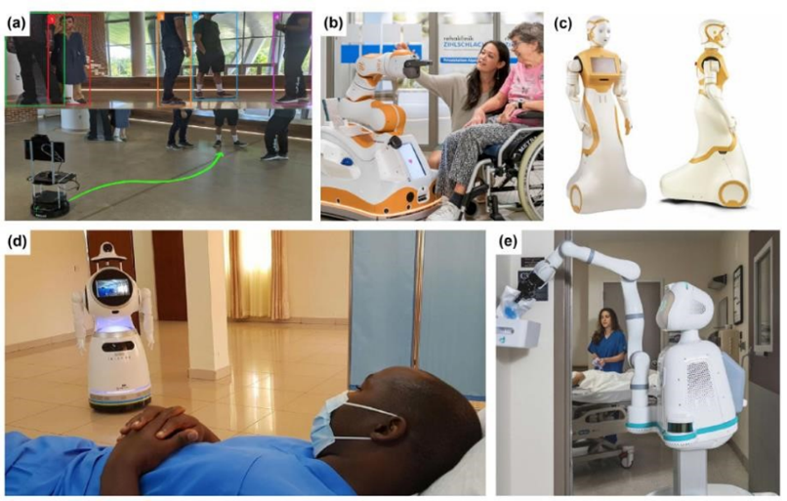

**2.2.2 designing of nurse robots**

*The newest PAL Robotics’ social robot ARI25 was conceived taking into account the previous challenges. ARI’(ASSISTIVE ROBOT ) user centered design has been focused on several key considerations:*

*• mobility,*

*• light weightless,*

*• safety,*

*• simplicity*

*• modernity.*

*The major goal has been to improve user acceptability of social robots. both by operators and end users, by making it more like human when it comes to both visual appearance and behavior features such as voice and movement. For this reason, ARI has been designed to resemble the human body, on the one hand considering a suitable body-head proportion and degree of iconicity Secondly, its height has been set to 1.65 cm, the average height of a female adult, adding two arms, human-like face and body form. In contrast to related robots in the market it is the one that most accurately mirror human’s appearance. Its covers are 3D printed with PA12 to obtain smooth surfaced to reduce risk of injury to people, with a low center of gravity and low mass of the upper limbs to minimize impact and fall risks.[7]*

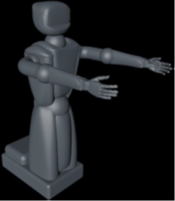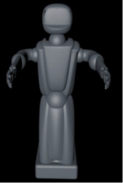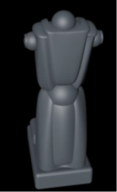

**2.2.3 Feature Of AL Robot**

These researches’ result should be used in order to minimize the robot size and its measuring tools and consequently reduce complexity and cost. Thus, this paper gives an example of BP estimation from PPG sensor by extracting some features from PPG signals which analysed by using machine learning (ML). More than 2000 recorded PPG and BP signals provided by Physio Net organization is used. shows the four features that are used including; first feature is heart rate that can be determined by peakto-peak interval of the PPG signals. The second, is augmentation index (AI) which is defined as the measurement of the wave reflection on the arteries and is calculated by ratio of the diastolic.[8]

**2.2.4 The Four Wheeled Wireless Medical Robot System**

*The MR has four direct current (DC) Motors of which each two motors are fixed in one side of the robot and aligned and powered by one of the motor driver, MR can turn right or left by differential steering velocity. The proposed medical robot (MR) is implemented and experimental test where a radio frequency (RF) controller is used to control the robot movement. The system used microcontrollers and sensors IR, respiratory rate, Blood Pressure, heart rate and body temperature.[9]*

***We used***

*is designed to reduce nurse workloads it can work intensively in risky environments, greatly reducing the unnecessary contact between the medical staff and patients because it is made by a PMMA Filament (acrylic) material, there-fore increasing healthcare workers’ safety and reduce their pressures, could help to reduce health care professionals’ exposure to disease. it will come to market as the number of coronavirus cases around the world grows, and frontline workers including doctors and nurses are feeling the pressure.*

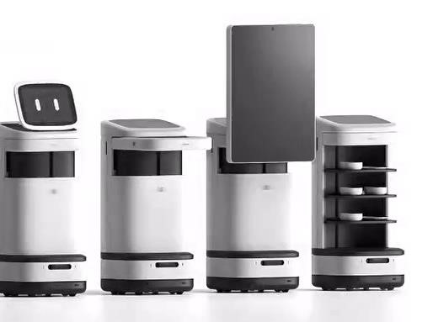

*The material we will use PMMA or polymethyl methacrylate (acrylic)is a strong, lightweight and transparent thermoplastic. It is commonly known as acrylic. PMMA filament has excellent impact strength that is significantly higher than glass. In addition, it has half the destiny of glass with comparable transparency and UV absorption properties.it has a high impact resistance which makes it tough and durable.*

*It’s also extremely rigid with very little flexibility. So, to print an object that will stand up to a certain amount of stress without bending or deforming, PMMA 3D printer filaments are a strong contender.*

*Features:*

* *This is an ideal material when you need a hard object, with little flex, with excellent finish quality and clarity.*
* *PMMA responds very well to post print finishing, such as sanding, drilling or engraving.*
* *PMMA lends itself perfectly to the process of lost wax casting due to its ability to burn away cleanly without residue.*
* *Pure resin quality.*
* *Clear, thermoplastic acrylic;*
* *Strong, rigid, lightweight, impact resistant;*
* *Available in several colors, including neutral, red, blue and green;*
* *Acetone soluble;*
* *Generally, not food safe;*
* *PMMA filament temperature prints from 245C to 255C; • Recommended printing bed temperature from 100C to 120C.*

**2.3.1 Automatic reminder to take medication**

*Hospitals have many patients and it is difficult to remind each patient to take medication on time. Traditional methods require human efforts to remind them to take medications on time. The digital age is not following that and we can use machines to do so. The Smart Medicine Reminder app is very wide and can be used by patients at home, doctors in hospitals, and in many other places. When it comes to reminders, there can be many ways to remind them:*

1. *On-screen display*
2. *Send a notification by email or phone*
3. *Use mobile apps*
4. *Tinnitus alarm*
5. *Using Bluetooth/Wi-Fi*
6. *-Get a phone call*
7. *Next treatment time reminder with current time reminder*

*To simplify things here, they made a simple reminder of when to take the medicine with Arduino which reminds them to take the medications once, twice, or three times a day. The time period can be determined using push buttons, and the project displays the current date and time.[10]*

**2.4 sensors**

**2.4.1 Blood Pressure Sensor**

*Blood Pressure (BP) is one of the important vital signs. It is the pressure exerted by the circulating blood on the walls of blood vessels. Blood Pressure is expressed as the ratio of the systolic pressure over diastolic pressure. Mercury sphygmomanometer is being used for measuring blood pressure. In this, the height of the column of mercury is considered for measuring the blood pressure. The oscillometric method is used for automated blood pressure measurements since 1981. With the advance in technology devices for measuring blood pressure through the non-invasive oscillometric method are being developed. One such device is the Blood Pressure Sensor.[11]*

***What is a Blood Pressure Sensor?***

*Blood Pressure can be measured both by invasive and non-invasive methods. In the non-invasive method, no piercing is required and is easy to use. Blood Pressure Sensor is used to measure the blood pressure using the non-invasive method.[3] It is similar to sphygmomanometer but instead of the mercury column, a pressure sensor is used to detect the blood pressure.*

***Working Principle***

*Usually, pressure cuff linked to a mercury column is used to measure the blood pressure. Here, the doctor manually pumps the cuff to increase the pressure on the artery. Then using stethoscope the noise of the blood rushing through the artery. In automatic Blood Pressure measurement system, instead of mercury a pressure sensor is used to detect the pressure in the artery and give output. This digital output is displayed on the monitor. This monitor has an onboard processor to process the output given by pressure sensor, record results and display them on the digital read-out screen.*

***Applications of Blood Pressure Sensor***

*This sensor is very important for High Blood Pressure patients, as it is also available as ‘at-home’ solid-state Blood Pressure Monitor. This system is portable. It is easy to carry and operate and highly useful in remote areas where medical facilities are not available. The main sensing element of this system is the pressure sensor present in the chuff. For an accurate and reliable measurement, this pressure sensor should be carefully selected. Honeywell’s 26 PC SMT pressure sensor is one of the examples of pressure sensors used in this system. This sensor is small, low-cost and can measure higher values of pressure. This sensor is used directly with the printed circuit board and can measure pressure faster and more accurately. As the sensor provides true surface mount capability, true installation cost of this sensor is very low. Using Oscillometric techniques this Sensor can measure systolic, diastolic, and mean arterial pressure. It can also measure the pulse rate. This automated system can be connected to the main power or used with batteries.[12]*

**2.4.2 Body Temperature Measurement**

*External temperature measurement has advanced in technology with the addition of sensor technologies, increasing patient comfort, improving accuracy, and creating better tools for monitoring. Its data can be crucial to patients suffering from various conditions, from infections to hypothermia. The temperature measurement of the surface of the body can be accomplished using body or skin temperature sensors. TE Connectivity (TE) manufactures NTC (negative thermal coefficient) thermistors, thermopiles, and digital temperature sensors to support the wide range of accuracy, packaging, and performance conditions amongst the different applications.*

*Infrared (IR) temperature sensors enable accurate non-contact temperature measurement in medical applications. The most common applications for this type of temperature sensor is measuring ear temperature, forehead temperature, or skin temperature. The sensing element is composed of multiple thermocouples on a silicon chip to measure an object's infrared energy. TE packages and customizes thermopiles in various package sizes and with different wire lengths to accommodate customer needs.[13]*

**2.4.3 Blood Oxygen Meters (Pulse Oximeters)**

*Medical devices to measure blood oxygen by placing a sensor on a thin part of the patient's body, usually the tip of the finger or earlobe, or in the case of the infant, through the foot. Compared to other methods, this method is safe, convenient and inexpensive.*

***Purpose of this device:***

*Arterial oxygen saturation is an essential vital sign that must be known to diagnose the patient's condition and make a medical decision in some cases, for example:*

*• Anesthesia*

*• Resuscitation*

*• Critical Care*

*• Childbirth*

*• Pulmonary diseases*

***Recommendations For Safe Use Of The Device:***

*The accuracy of reading the device is high, but (the error rate may range between 2% and 5%), and its reading may be affected by several factors, including: movement, blood perfusion, skin thickness, skin color, low blood pressure, obesity, anemia, and other factors and reasons that affect the accuracy of reading. To ensure the accuracy of the device's readings, the following is recommended Remain calm and immobile when taking the reading Continue to breathe normally*

* *Take the reading in a room with a moderate temperature*
* *Monitor symptoms of low blood oxygen such as: shortness of breath (12-18 breaths/minute for adults), change in the color of the skin, nails or lips, headache, rapid heartbeat, cough, and other symptoms.*
* *Consult a doctor if the reading is low or if there are symptoms of low oxygen in the blood (the normal percentage is usually 95% and higher).*
* *Do not rely on the results of the blood oxygen meter to diagnose COVID-19 or other lung diseases.*
* *Make sure that the device or medical requirement has a marketing permission from the Saudi Food and Drug Authority*
* *Use the device or the necessary according to the instructions and instructions attached to it from the manufacturer.*

***Mechanism***

*A blood-oxygen monitor displays the percentage of blood that is loaded with oxygen. More specifically, it measures what percentage of hemoglobin, the protein in blood that carries oxygen, is loaded. Acceptable normal SaO2 ranges for patients without pulmonary pathology are from 95 to 99 percent For a person breathing room air at or near sea level, an estimate of arterial pO2 can be made from the blood-oxygen monitor "saturation of peripheral oxygen" (SpO2) reading.[1]*

***Mode of operation***

*A typical pulse oximeter uses an electronic processor and a pair of small light-emitting diodes (LEDs) facing a photodiode through a translucent part of the patient's body, usually a fingertip or an earlobe. One LED is red, with wavelength of 660 nm, and the other is infrared with a wavelength of 940 nm.*

*Absorption of light at these wavelengths differs significantly between blood loaded with oxygen and blood lacking oxygen. Oxygenated hemoglobin absorbs more infrared light and allows more red light to pass through. Deoxygenated hemoglobin allows more infrared light to pass through and absorbs more red light. The LEDs sequence through their cycle of one on, then the other, then both off about thirty times per second which allows the photodiode to respond to the red and infrared light separately and also adjust for the ambient light baseline. The amount of light that is transmitted (in other words, that is not absorbed) is measured, and separate normalized signals are produced for each wavelength.*

*These signals fluctuate in time because the amount of arterial blood that is present increases (literally pulses) with each heartbeat. By subtracting the minimum transmitted light from the transmitted light in each wavelength, the effects of other tissues are corrected for, generating a continuous signal for pulsatile arterial blood.*

*The ratio of the red light measurement to the infrared light measurement is then calculated by the processor (which represents the ratio of oxygenated hemoglobin to deoxygenated hemoglobin), and this ratio is then converted to SpO2 by the processor via a lookup table based on the Beer–Lambert law. The signal separation also serves other purposes: a plethysmograph waveform ("pleth wave") representing the pulsatile signal is usually displayed for a visual indication of the pulses as well as signal quality, and a numeric ratio between the pulsatile and baseline absorbance ("perfusion index") can be used to evaluate perfusion.[15]*

**2.4.4 Heart Rate Sensor**

*The science of smart watches :*

*Personal fitness monitoring is a multi-billion pound industry and wearable devices like smart watches are now commonplace. This article explains how smart watches use light to measure heart rate and other health metrics like oxygen saturation and looks at where recent advances in materials, sensor and battery technology could lead. It’s accompanied by a downloadable resource with a practical spectroscopy activity for the 16-18 age group. The principle behind the blinking of the green light is that our blood color is red, so it reflects the red light and absorbs the green light. All types of smart watches use similar principle to tell heart rate, sleep, stress, etc. Secondly, this green light also blinks during activity tracking.*

*According to the research, green light emitted by a smart watch is safe for the human body, as these lights have a low frequency. This light is the same as natural light, which is not harmful. Secondly, green light from any smart watch has non-ionizing nature, which is safe and doesn’t damage cells.[16]*

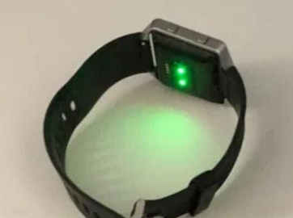

**2.5.1 OVERVIEW OF ARDUINO CHARACTERISTICS**

*Arduino is essentially a micro-controller mounted on a board with the circuitry required to connect sensors and actuators in an easy manner. In other words, it is an embedded prototyping board designed for electronics projects that demand repeated execution of some tasks (Costa and Duran-Faundez, 2018). It must be noted that Arduino is not a micro- processor/computer like for example Raspberry Pi, therefore, it has not embedded operating system.*

*Arduino chips are based on micro-controllers manufactured by Atmel, mainly of the familyATmega. It was originally designed and manufactured in Italy, in a project that started in 2005.The GNU General Public License (GPL) allows the manufacture of Arduino boards and software distribution by anyone.*

*Some popular models are: Uno, Mega, Yun, Due,Nano, Duemilanove, Extreme, Lilypad, just to name a few.*

*Hence, the developer is able to select the model that fits better the application to deploy. In (Costa and Duran-Faundez, 2018) a detailed overview and comparison of different open-source platforms, including Arduino, can be found.*

*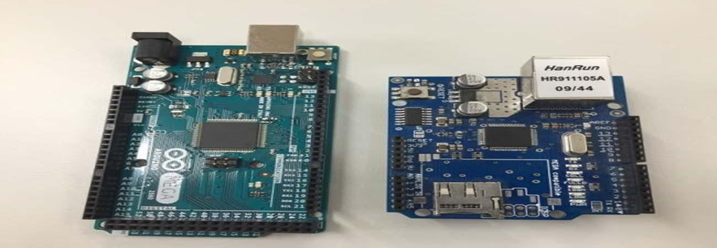The expansion boards, called shields, provide a number of enhancements of the Arduino functionalities and resources. Some examples of shields are those devoted to data storage through Secure Digital (SD) cards, Global Positioning System (GPS) functionality, direct connection of sensors/actuators, etc. About connectivity options, there are diverse shields to support communication means both wired and wireless. Some examples or wired links are RS-232, RS-485, and Ethernet. Available wireless means are Bluetooth, WIFI, ZigBee, Global System for Mobile communications (GSM), General Packet Radio Service (GPRS), or Radio Frequency Identification (RFID). Figure 1 shows the aspect of an Arduino Mega and an Ethernet shield. Concerning the software, to program and configure Arduino chips the open-source Integrated Development Environment (IDE) is freely available. IDE uses a programming language based on a simplified version of the C++ language. It runs in a computer to which the board must be connected via Universal Serial Bus (USB) communication. This software allows designing the code for Arduino as well as to monitor its operation through the serial port of the computer. It includes a number of in-built programs to facilitate the learning and development of the applications.*

*Additionally, some software packages widely used in scientific and industrial environments like Matlab or LabVIEW already include communication options to exchange data with Arduino boards. For instance, the LabVIEW Interface for Arduino (LIFA) toolkit enabled the data sharing between a virtual instrument of LabVIEW and an Arduino board through an USB connection.*

*There also exist web pages devoted to store, visualize and analyse data gathered by Arduino boards like thingspeak.com, facilitating and promoting the integration of these boards with cloud and IoT resources. Among the advantages of the Arduino, the most relevant ones are now listed:*

* *Open-source nature. Schematics, code and documentation related to Arduino and to the associated shields are available in the Internet.*
* *Low-cost components. The boards of Arduino as well as the shields and sensors/actuators are inexpensive.*
* *Easy-to-use. The time and effort required to develop and deploy Arduino-based systems are shorten due to the abovementioned availability of information.*
* *Community support. A large number of tutorials, forums and videos supports knowledge sharing, facilitating Arduino-based projects.*
* *New products and software continuously released. The open-source community constantly increases resources like libraries and shields, contributing to enhance existent arrangements or to design novel systems.*

**2.5.2 Brain of Robot (Arduino Mega)**

*The brain of the robot is connected with different sensors and actuators of the robot. The sensors are the input to the brain and the output of the robot is executed using actuators. The brain of the robot is responsible for reading the data from sensors, perform different computations on the sensor data, and make a decision based on the data. The decisions made by the robot brain can be executed using different actuators.*

*There is a different type of microcontroller used in robotics such as Arduino. Arduino is an open-source microcontroller which can be easily programmed, erased, and reprogrammed at any instant of time. Introduced in 2005 the Arduino platform was designed to. It is also capable of receiving and sending information over the internet with the help of various Arduino shields, which are discussed in this paper.*

*Arduino uses hardware known as the Arduino development board and software for developing the code known as the Arduino IDE (Integrated Development Environment). Built up with the 8- bit Atmel AVR microcontrollers that are manufactured by Atmel or a 32-bit Atmel ARM, these microcontrollers can be programmed easily using the C or C++ language in the Arduino IDE.*

*There are several types of Arduino boards such as Mega. Arduino Mega is based on ATmega2560 Microcontroller, an 8-bit AVR Architecture-based MCU from ATMEL. It is available in a 100-pin Quad Flat Package. It is designed and developed to provide a greater number of IO lines (both Digital and Analog), more flash memory, and more RAM when compared to UNO.[17]*

**2.5.3 Related work**

*Ahmed Dridi proposed the SM-IoT platform for intelligent and personalized healthcare, dedicated to patients. The aim of this platform is to improve the remote patient monitoring and promote healthcare services. By using SM-IoT platform is able to collect data from heterogeneous information sources, integrate them by using a flexible semantic web, store them in the cloud for further analysis, visualized these data with user-friendly interfaces and facilitate their sharing by taking into account their privacy aspect. Noha MM.[18]*

*Abdelavi presented the survey on Internet of Things Technologies and Project for health care services. In that they provide an overview of the main medical sensors in IoT and a*

*review of the current state-of the-art of IoT projects, and technologies required for healthcare services. Mainly focused how IoT could be useful and contribute to improve the quality of life.[19]*

*Amandeep Kaur proposed a system used for monitoring the pulse rate, body temperature of patients by using sensors with Raspberry Pi and IoT. The system proposed is a wearable and it supports remote health monitoring and the data are stored to Bluemix cloud, and data are retrieved by doctor for diagnostics. Bluemix cloud uses a protocol called MQTT (Message Queuing Telemetry Transport) that is used for sending and receiving messages. Patient’s temperature is monitored by using DS18B20 sensor and heart rate by using KG011 sensor.[1]*

*Jayapradha., presented a paper that contains various IoT applications and also explained the role of IoT in healthcare, challenges in healthcare system using IoT and also introduced a secured surveillance monitoring system that is used for reading and storing details of patient’s using low power for transmitting the data. [2]*

*Himadri Nath Saha., proposed a system that monitors vital health parameters and data are transmitted to a network through a Wi-Fi module. The data can be accessed at any time. In case of any abnormal behaviour or any kind of a vital sign is recognized the nurse and doctors are notified immediately through a buzzer. Cloud computing and password protected Wi-Fi that plays an important role in security by handling authentication and secure patient details by allowing a restricted access to the database.[3]*

*Mohamed Elhassan. proposed a hybrid security model for securing diagnostic text data of medical images and developed a model by integrating 2D discrete wavelet transform 1 level or 2D discrete wavelet transform 2 level steganography technique along with a proposed hybrid encryption scheme. The hybrid encryption scheme is built by combining Advanced Encryption Standard (AES) and Rivest , Shamir, and Adleman (RSA) algorithm.[4]*

*Shreya Rajkumar, Malavika Srikanth,” proposed a health monitoring system which monitors vital parameters of the patient such as temperature and heart rate using sensors as well as a Fitbit which are connected to a raspberry pi board.[5]*

*Zainab Alansari, Nor Badrul Anuar and Amir Rudin,” carried a study on distinguishes different users of IoT in healthcare systems as well as its functions and preferences, this study gives a detailed view on healthcare system based on Internet of Things (IoT). The Fuzzy Analytic Hierarchy Process (FAHP) along with the development analysis of Chang, Da-Yong has been used to prioritize the IoT adoption in healthcare applications.[6]*

*Solving health issues using the latest technology based on Internet of Things (IoT) was proposed by Durga Amarnath and M Budida,” they presented the architectural review of smart healthcare system using Internet of Things (IoT) which is aimed to provide a Better HealthCare to everyone.[7]*

*Chengathir Selvi M., proposed a system that process sensor data and provides real time monitoring conditions to doctors they can access from anywhere in the world.[8]*

**2.6 communication system**

*IoT technology makes certain physical events can have an impact on other things remotely. Using this technology can execute controlling or monitoring something somewhere in the world. Additionally, this technology provides a communication channel between human-to-human, human-to-smart devices, and smart devices-to-smart devices without human interaction. IoT applications have been increasing by the time such as smart wearable devices, smart cities, home automation, remote control, and monitor systems.*

*Also, IoT technology has a modern evolution in healthcare systems and fitness applications. This can be an essential step to change the conventional healthcare systems which require patients’ existence inside hospitals or clinic centers to check their health parameters. On the other hand, there are some challenges of this technology such as data management, security, privacy, human-cloud interface.[9]*

*IoT technology utilizes diverse types of communication protocols for example (IPv6) Wi-Fi, (IPv4) Wi-Fi, 6LoWPAN, ZigBee, (BLE) Bluetooth Low Energy, Z-Wave, (NFC) Near Field Communication, SigFox, 2G-3G-4G Cellular, Thread, and Lora WAN. Each protocol has distinguished properties that allow IoT project designers to use any protocol to meet their requirements and limits.[10]-[11]*

***We used:***

**2.6.1 Wi-Fi module**

*from sensors to mobile application “Blynk”. Moreover, NodeMCU and Arduino UNO microcontrollers are applied. Arduino microcontroller family has been used in many fields and it is considered in many experimental models and prototypes. Furthermore, the IoT platform is Blynk mobile application. It receives, stores, visualizes data, and provides hardware control remotely.*

*To use Blynk four steps must be accomplished such as downloading the mobile app from Apple Store or Google Play, installing its libraries on the developer PC, creating widgets inside the app, building the desired hardware design and writing code. There are a lot of examples in “examples.blynk.cc” to make users familiar with Blynk code standards. Moreover, this IoT platform includes, besides the Blynk application, the Blynk server which provides a communication channel between the IoT project’s hardware and the cloud. This server can be built on a Blynk cloud or a local server in case the IoT system is used in a limited area. Finally, Blynk libraries are responsible to communicate between the server and the processing instructions.*

*The impactful thing in Blynk that it is installed in a caregiver smartphone so, the interface layout is constructed on that phone only. This means that no one can see the data except the caregiver. This keeps the data private and secure. Finally, this application delivers an opportunity to monitor more than one patient at the same time by creating a new page for each patient.[12]-[13]*

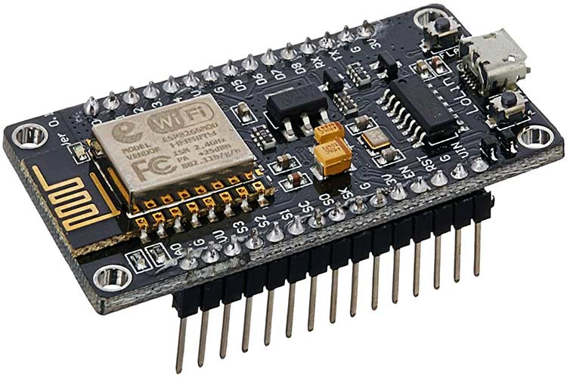

**2.6.2** **cellular (GSM)**

*GSM module for radiation safety instruments such as survey meter and area monitor. The module is intended for wireless monitoring and early emergency warning. Data transmission involves radiation measurement data, instrument status, and configuration parameters that did not require big bandwidth or high transfer speed. On the other hand, reliability of the data to be sent on time, no data loss, low power consumption and low telecommunication signal are crucial. Hence the Short Messaging Service or SMS fits perfectly as it enable the device to reliably send data at low signal, and no data loss.*

*Hardware and firmware development of the GSM module were done in parallel. Initially, the firmware was developed on Arduino platform; Arduino and GSM Shield for Arduino. The Serial Monitor in Arduino IDE is a very useful tool to echo communication between the microcontroller and GSM shield. This tool enables programmer to monitor and verify firmware operation in GSM shield responds and SMS data processing. Hence, the proof-of-concept prototype is successfully developed on Arduino platform. However, the Arduino GSM library was not utilized; instead, the microcontroller communicates with GSM shield by using AT Command to avoid dependency on the library as well as to maintain the flexibility of the firmware.[14]*

***Hardware Design***

*A customized PCB is designed to create a single board that housed all the necessary design blocks as shown in figure. The voltage regulator circuit provides voltage supply to all the components on board based on their respective voltage specifications. Microcontroller Atmega328P controls and synchronizes the operation of the module; it controls the operation of GSM module, and handles data and commands from the external device. Telit GL865-DUAL/QUAD V3 module (Telit) is a compact GSM/GPRS module that suits portable and battery-operated device. This IC acts as GSM modem that transmits and receives all the SMS for the GSM module.*

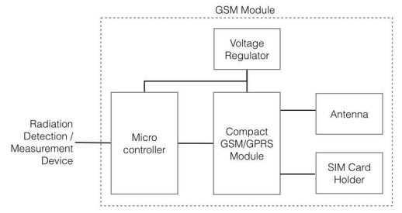

*The PCB is designed based on Telit design recommendation. Voltage regulators are 3.8 Volts for GSM Module and 3.3 Volts for Atmega328P microcontroller. The compact size enables the PCB to be easily incorporated into the same enclosure of survey meter/area monitor or small compact casing for external connection.*

*Communication between GSM module and microcontroller is done using AT commands by using standard serial connection [2]. The GSM module is designed to enable wireless communication for radiation monitoring instrument intended for continuous data monitoring and emergency alert. There are three configuration parameters that are essential to complete the task; the Host number, time interval for data transmission, and threshold level for alert SMS. These parameters are stored in EEPROM of microcontroller. User will be able to change and update the configuration parameters via SMS. The firmware is responsible to handle task related to GSM/SMS communication with the Host server.[15]*

**2.6.3** **platforms**

*There are various types of IoT platforms. Some of them are created via developers from scratch using web design skills such as Node.js server and WebSocket library also, HTTP server and the developed webbased GUI interface. On the other hand, Android Studio provides a good opportunity for mobile.[16]*

*application developers to build up their own healthcare applications, so, some projects depend on that approach. For example, one mobile application is called “Abuelómetro” and another one is called “3rd Nurse”.[17]*

*Additionally, there are some mobile applications are created for IoT projects in general. As a result, these types of applications can be utilized for healthcare systems such as Blynk mobile application.*

*Data storage can be achieved by two methods. One is by storing data in an online (cloud-based) database such as MySQL and Google Firebase Database. However, the other projects depend on the mobile applications server. This approach is considered less complex than the first approach. For example, Blynk and Abuelómetro applications save health data on their server.[18]*

***We used***

*After all the individual implementations, all the sensor implementations were merged into a single functioning system. The data was stored in the Google Firebase RealTime Database which can be accessed by an Android Software. The developed software has been titled as the 3rd Nurse, which had a very simple user interface for easy understanding of the application.*

**2.7 Mobile Application**

*The Android app was developed using Android Studio. It has features of monitoring the health stats of a patient and allows the personnel monitoring to monitor from distance. However, anything on the cloud has a risk of leakage of* *privacy. To prevent that, the application is encrypted with login credentials for safety purposes.*

*In addition, the user can select the modes of monitoring, Doctor, Personal, and Relatives. Each of this mode is assigned with a unique ID that can only be permitted by the patient itself. The following figure shows the display of such a feature.*

*Once, the person monitoring can access the patient’s ID, the monitor is displayed with a page consisting of real-time data of body temperature, heart rate, and GSR respectively as shown in the following figure. In addition, the Doctors can prescribe the patient by simply monitoring the patterns of his health status by analysing the past-present recordings. This is a very unique feature which enables both the patient and the doctor to keep a track of the patient’s prescription.[19]*

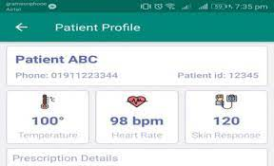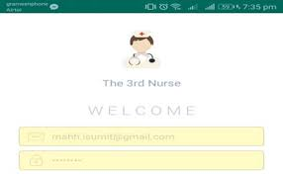

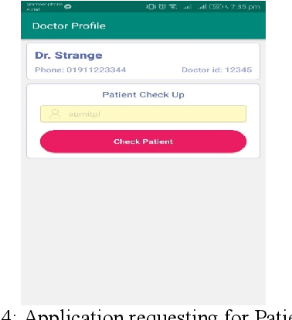

*Ex1: Healthcare Monitoring System project in Gujarat Technological university in Ahmedabad, India: Detailed Module Description:*

* *Registration: Sign-up: Helps user to register themselves by providing basic details to the system database for future use. Fields mentioned here should be filled accordingly as per validation criteria. Login: This helps already register patient and doctor to access the portal by login tab. There are 3 types of logins: Patient Login, Doctor Login and Laboratory Login.*
* *Predict disease: Here the user has to enter the appropriate symptoms in the required field to predict the most probable disease on the basis of the symptoms entered.*
* *Appointment: This portal helps setting appointment with doctor on appropriate date and time after getting your diseases detected. The user can move from this page to appointment or can move to home for making another prediction.[20]*

*Ex2:* *Research on IoT-Based Smart Health Monitoring System for COVID-19 Patients:*

*Mobile Application Interface: The mobile application had nine interfaces. The mobile application known as the SpO2 analyser.*

*The application interfaces are shown as:*

* *First interface: shows the login interface of the mobile application. Old users can login by using their username and password, and new users need to sign up to login.*
* *Second and third interface: Sign up interface of mobile application and successful sign up.*
* *Forth interface: User’s portal interface of mobile application.*
* *Fifth and sixth interface: Normal user interface of mobile application. Measured SpO2, pulse rate, and temperature.*
* *Seventh and eighth interface: Doctor portal interface of mobile application. Normal patient portfolio of mobile application.*
* *Ninth interface: Measured SpO2, pulse rate, and temperature.[21]*

**References**

1. *White F (2015). "Primary health care and public health: foundations of universal  
   health systems".*
2. *White F, Stallones L, Last JM. Global Public Health – Ecological  
   Foundations. Oxford: Oxford University Press; 2013. chapt 8 .*
3. *(Catlin et al., 2008)..*
4. *Donev D, Ivanovska L, Lazarevski P, Ruzin N. Glossary of Social Protection  
   Terms. Phare Consensus Programme Project: Dictionary and Glossary of Social  
   Protection Terms. European Commission, 2000:472.*
5. *Association of American Medical Colleges (AAMC), study published,2016.*
6. *IEEE Foundation COVID-19 Fund Supports Five Programs–IEEE  
   Spectrum. Accessed: Nov. 7, 2020.*
7. *E. Broadbent, V. Kumar, X. Li, J. Sollers 3rd, R. Q. Stafford, B. A.  
   MacDonald, and D. M. Wegner, “Robots with display screens: a robot  
   with a more humanlike face display is perceived to have more mind  
   and a better personality,” PloS one, vol. 8, no. 8, p. e72589, 2013*
8. *UCI Machine Learning Repository: Citation Policy. (n.d.). Retrieved February 23, 2021*
9. *Takahara S, Jeong S. Prototype design of robotic mobility aid to assist elderly's standing sitting, walking, and wheelchair driving in daily life. In: International Conference on Control, Automation and Systems. Seoul: IEEE Computer Society; (2014). p. 470–3.*
10. *David Kushner:"The Making of Arduino. How five friends engineered a small circuit board that’s taking the DIY world by storm". IEEE Spectrum, 2011-10-26 (2015eko otsailaren 21ean ikusia)Archived2021-01-26 at theWayback Machine*
11. *Booth, J (1977). "A short history of blood pressure measurement". Proceedings of the Royal Society of Medicine. 70 (11): 793–9.*
12. *doi:10.1177/003591577707001112. PMC 1543468. PMID 341169. Chandrasekhar, Anand (2018-03-07). "Smartphone-based blood pressure monitoring via the oscillometric finger-pressing method". Science Translational Medicine. 10 (431): eaap8674. doi:10.1126/scitranslmed.aap8674. PMC 6039119. PMID 29515001.*
13. *Marx J (2006). Rosen's emergency medicine : concepts and clinical practice (6th ed.). Philadelphia: Mosby/Elsevier. p. 2239. ISBN 978-0-323-02845-5. OCLC 58533794.*
14. *"Principles of pulse oximetry". Anaesthesia UK. 11 Sep 2004. Archived*
15. *from the original on 2015-02-24. Retrieved 2015-02-24.Nitzan M, Romem A, Koppel R (2014). "Pulse oximetry: fundamentals and technology update". Medical Devices: Evidence and Research. 7: 231–239. doi:10.2147/MDER.S47319. PMC 4099100. PMID 25031547.*
16. *Musil, Steven. "One in 10 American adults expected to have a smartwatch next year". CNET. Retrieved 2019-05-12.*
17. *inproceedings{inproceedings,author = {Louis, Leo},year={2018},month = {07},pages = {},title ={Working Principle of Arduino and Using it as a Tool for Study and Research},volume = {1},journal {International Journal of Control,Automation,CommunicationandSystems},doi={10.5121/ijcacs.2016.1203}.*
18. *Ahmed Dridi, Salma Sassi,"A Smart IoT platform for personalized healthcare monitoring using semantic technologies”, 2017 International Conference on Tools with Artificial Intelligence.*
19. *Noha MM. AbdElnapi, Nahla F. Omran,"A survey of Internet of Things Technologies and projects for health care service”, 2018 International Conference on Innovative Trends in Computer Engineering (ITCE 2018), Aswan University, Egypt.*
20. *Amandeep Kaur, Ashish Jasuja,"Health Monitoring Based on IoT using RASPBERRY PI”, International Conference on Computing, Communication and Automation (ICCCA2017).*
21. *S. Jayapradha, P.M Durai Raj Vincent,"An IOT based Human healthcare system using Arduino Uno board”, 2017 International Conference on Intelligent Computing.*
22. *Himadri Nath Saha, Shreyaasha Chaudhury, Ruptirtha Mukherjee, Debasmita Paul, Siddhartha Haldar,” Internet of Thing Based HealthCare Monitoring System”.*
23. *Mohamed Elhoseny, Gustavo Ramírez-González, Osama M. Abu-Elnasr, Shihab A. Shawkat, Arunkumar N, Ahmed farouk,” Secure Medical Data Transmission Model for IoT-based Healthcare Systems”, Citation information: DOI 10.1109/ACCESS.2018.2817615, IEEE Access.*
24. *Shreya Rajkumar, Malavika Srikanth,“Health Monitoring System using Raspberry PI”, 2017 International Conference on Big Data, IoT and Data Science (BID), Vishwakarma Institute of Technology, Pune, Dec 20-22, 2017.*
25. *Zainab Alansari, Nor Badrul Anuar and Amirrudin,“The Internet of Things Adoption in Healthcare Applications”, 2017.*
26. *Durga Amarnath, M. Budida,"Design and Implementation of Smart HealthCare System Using IoT”, 2017, International Conference on Innovations in Information, Embedded and Communication Systems (ICIIECS).*
27. *Chengathir Selvi. M, T.D. Rajeeve, A.John Paul Antony, Prathiba. T,"Wireless Sensor Based Healthcare Monitoring System Using Cloud”, International Conference on Inventive Systems and Control (ICISC-2017).*
28. *B. Farahani, F. Firouzi, V. Chang, M. Badaroglu, N. Constant, and K. Mankodiya, 2018 Towards fog-driven IoT eHealth: Promises and challenges of IoT in medicine and healthcare, Future Generation Computer Systems, 78, pp. 659-676.*
29. *S. Al-Sarawi, M. Anbar, K. Alieyan, and M. Alzubaidi, 2017 Internet of Things (IoT) communication protocols, in 2017 8th International conference on information technology (ICIT), pp. 685-690: IEEE.*
30. *L. M. Dang, M. Piran, D. Han, K. Min, and H. Moon, 2019 A survey on internet of things and cloud computing for healthcare, Electronics* ***8*** *(7), p. 768.*
31. *I. J. Hasan, N. A. J. Salih, N. I. Abdulkhaleq, and M. J. Mnati, 2019 An Android smart application for an Arduino based local meteorological data recording, IOP Conference Series: Materials Science and Engineering 518 (4), p. 042014.*
32. *N. A. J. Salih, I. J. Hasan, and N. I. Abdulkhaleq, 2019 Design and implementation of a smart monitoring system for water quality of fish farms, Indonesian Journal of Electrical Engineering and Computer Science, 14 (1), pp. 44-50.*
33. *Projects M 2015 The Evil Goat (Arduino Project) 102–103.*
34. *Zhang L, Wang X, Wang C, and Gu X 2011 The application of stolen radioactive source tracking system based on internet of things technology Proc. 3rd Int. Conf. on Measuring Tech. and Mechatronics Automation ICMTMA 2011 3 696–698.*
35. *L. A. Durán-Vega et al., 2019 An iot system for remote health monitoring in elderly adults through a wearable device and mobile application, Geriatrics, 4 (2), p. 34.*
36. *Z. Yang, Q. Zhou, L. Lei, K. Zheng, and W. Xiang, 2016 An IoT-cloud based wearable ECG monitoring system for smart healthcare, Journal of medical systems, 40 (12), p. 286.*
37. *M. Taştan, 2018 IoT Based Wearable Smart Health Monitoring System, Celal Bayar Üniversitesi Fen Bilimleri Dergisi, 14 (3), pp. 343-350.*
38. *“IoT architecture in a nutshell and how it works” [Online]https://www.scnsoft.com/blog/iot-architecture-in-a-nutshelland-how-it-works accessed on 28th July 2018*
39. [*https://www.academia.edu/39295685/_Healthcare_Monitoring_System*](https://www.academia.edu/39295685/_Healthcare_Monitoring_System)*.*
40. [*https://www.hindawi.com/journals/cmmm/2021/8591036*](https://www.hindawi.com/journals/cmmm/2021/8591036)*.*

1. Amandeep Kaur, Ashish Jasuja,"Health Monitoring Based on IoT using RASPBERRY PI”, (ICCCA2017).
2. S. Jayapradha, P.M Durai Raj Vincent,"An IOT based Human healthcare using Arduino Uno board”, 2017.
3. Himadri Nath Saha, Shreyaasha Chaudhury, Ruptirtha Mukherjee, Debasmita Paul, Siddhartha Haldar,”

   Internet of Thing Based HealthCare Monitoring System”.
4. Mohamed Elhoseny, Gustavo Ramírez-González, Osama M. Abu-Elnasr, Shihab A. Shawkat, Arunkumar N, Ahmed farouk,” Secure Medical Data Transmission Model for IoT-based Healthcare Systems”,
5. Shreya Rajkumar, Malavika Srikanth,“Health Monitoring System using Raspberry PI”, 2017 International

   Conference on Big Data, IoT and Data Science (BID), Vishwakarma Institute of Technology, Pune, Dec 20-

   22, 2017.
6. Zainab Alansari, Nor Badrul Anuar and Amirrudin,“The Internet of Things Adoption in Healthcare

   Applications”, 2017.
7. Durga Amarnath, M. Budida,"Design and Implementation of Smart HealthCare System Using IoT”, 2017,

   International Conference on Innovations in Information, Embedded and Communication Systems (ICIIECS).
8. Chengathir Selvi. M, T.D. Rajeeve, A.John Paul Antony, Prathiba. T,"Wireless Sensor Based Healthcare

   Monitoring System Using Cloud”, International Conference on Inventive Systems and Control (ICISC-2017).
9. B. Farahani, F. Firouzi, V. Chang, M. Badaroglu, N. Constant, and K. Mankodiya, 2018 Towards fog-driven IoT eHealth: Promises and challenges of IoT in medicine and healthcare, Future Generation Computer Systems, 78, pp. 659-676.
10. S. Al-Sarawi, M. Anbar, K. Alieyan, and M. Alzubaidi, 2017 Internet of Things (IoT) communication protocols, in 2017 8th International conference on information technology (ICIT), pp. 685-690: IEEE.
11. L. M. Dang, M. Piran, D. Han, K. Min, and H. Moon, 2019 A survey on internet of things and cloud computing for healthcare, Electronics 8 (7), p. 768.
12. I. J. Hasan, N. A. J. Salih, N. I. Abdulkhaleq, and M. J. Mnati, 2019 An Android smart application for an Arduino based local data recording, IOP Conference : Materials Science and Engineering 518 (4), p. 042014.
13. N. A. J. Salih, I. J. Hasan, and N. I. Abdulkhaleq, 2019 Design and implementation of a smart monitoring system, Indonesian Journal of Electrical Engineering and Computer Science, 14 (1), pp. 44-50.
14. Projects M 2015 The Evil Goat (Arduino Project) 102–103.
15. Zhang L, Wang X, Wang C, and Gu X 2011 The application of stolen radioactive source tracking system based on internet of things technology Proc. 3rd Int. Conf. on Measuring Tech. and Mechatronics Automation ICMTMA 2011 3 696–698.
16. L. A. Durán-Vega et al., 2019 An iot system for remote health monitoring in elderly adults through a wearable device and mobile application, Geriatrics, 4 (2), p. 34.
17. Z. Yang, Q. Zhou, L. Lei, K. Zheng, and W. Xiang, 2016 An IoT-cloud based wearable ECG monitoring system for smart healthcare, Journal of medical systems, 40 (12), p. 286.
18. M. Taştan, 2018 IoT Based Wearable Smart Health Monitoring System, Celal Bayar Üniversitesi Fen Bilimleri Dergisi, 14 (3), pp. 343-350.
19. “IoT architecture in a nutshell and how it works” [Online]https://www.scnsoft.com/blog/iot-architecture-in-a-nutshelland-how-it-works accessed on 28th July 2018
20. https://www.academia.edu/39295685/_Healthcare_Monitoring_System.
21. https://www.hindawi.com/journals/cmmm/2021/8591036.